OpenSSHD configuration to connect to windows(2019 and later) hosts from ansible control node(ubuntu for eg)

Note: Other windows server version, winRM to be configured provided pywinrm package is installed in ansible control node

**Automatic Configuration:**

1. Run below command from PS (run as admin)

*Get-WindowsCapability -Online | Where-Object Name -like ‘OpenSSH*’*

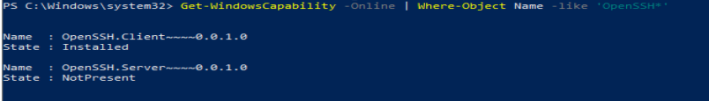

It showing as NotPresent. So we need to install it

1. Run below command to configure it

*Add-WindowsCapability -Online -Name OpenSSH.Server~~~~0.0.1.0* #you can get this from previous command output

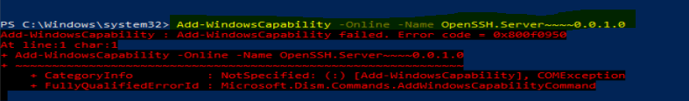

1. If it fails, then try install the OpenSSH from Server Manager feature. Make sure you update the windows updates and restart the server.
2. If none of the above process doesn’t work for auto configuration of OpenSSH, go for manual process as mentioned in the below steps

**Manual OpenSSH configuration steps:**

1. **Download from git openssh for windows**

[Releases · PowerShell/Win32-OpenSSH (github.com)](https://github.com/PowerShell/Win32-OpenSSH/releases/)

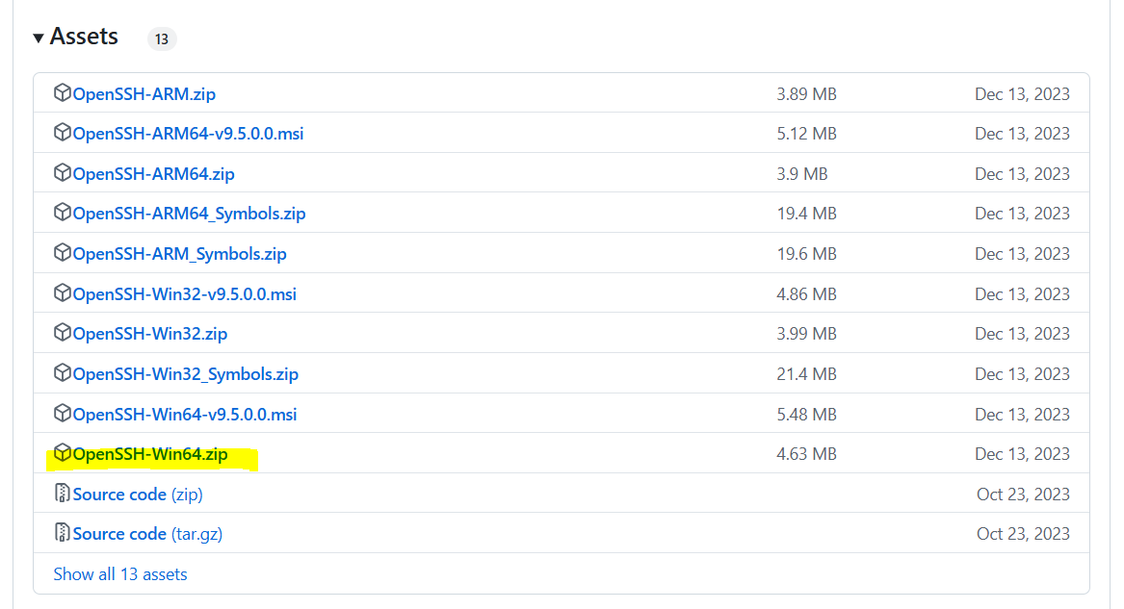

1. Install it by running the install-sshd.ps1 from the downloaded files
2. Start openssh and agent services and setup as auto startup services through powershell

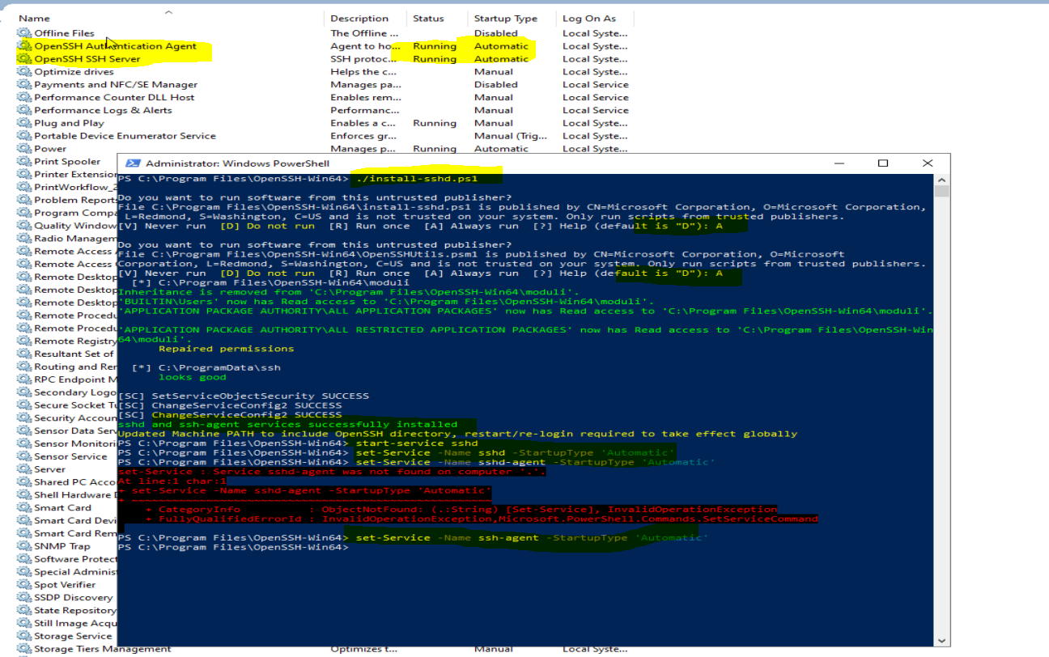

1. Open port 22 inbound firewall rule

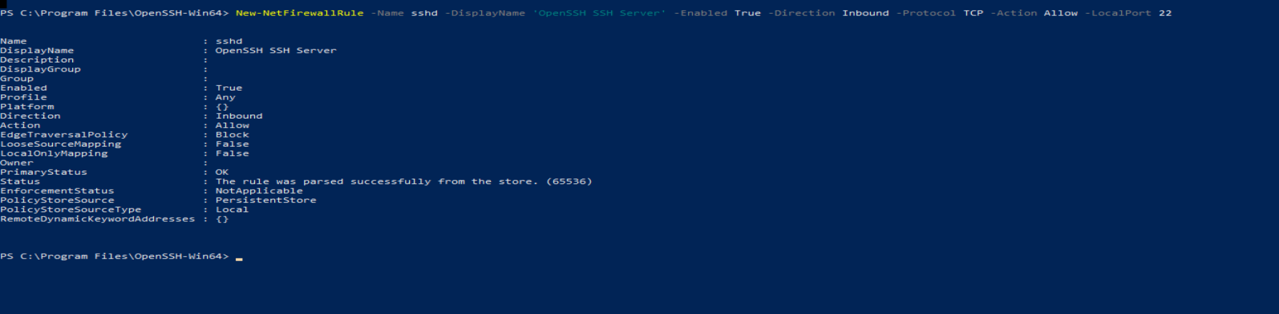

Note: open fileshare and print inbound rules(IPV4 and IPV6) to make the server pinged(icmp) from other servers or vms

1. Now we can use ssh sql3@sql3 #windows node ping test from control node or other nodes/vms
2. If above one doesn’t work, try with IP address, it will route the bash to sql3 server.

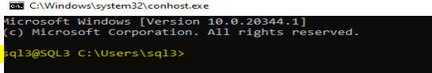

1. From WSL ubuntu in the same VM, we can test SSH conectivity to the OpenSSH configured windows server

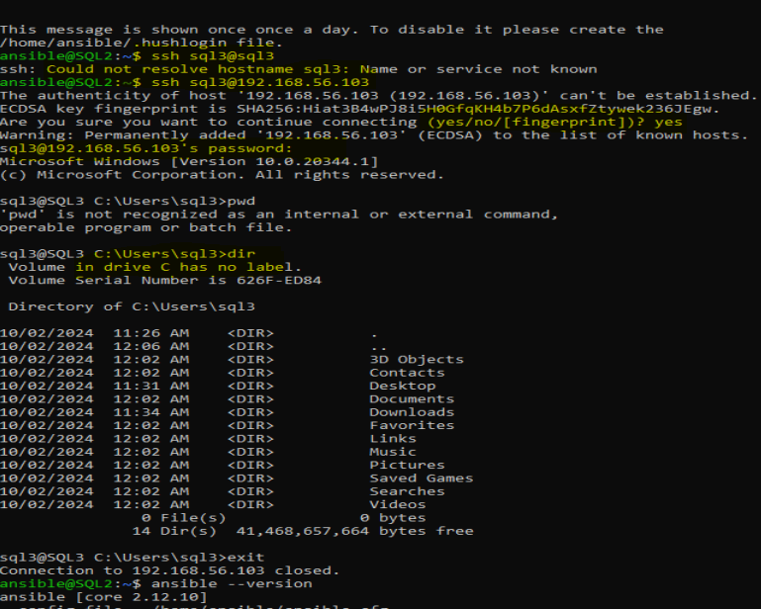

If you have issues with running powershell commands from ansible and are failing with parameter format not correct error

Make sure the Remote Execution policy is enabled on the hosts

If ssh is working fine and powershell commands working without issue after logging remotely to the hosts through ssh then you may have to change the shell type to cmd from powershell and wrapping poweshell commands inside the cmd shell

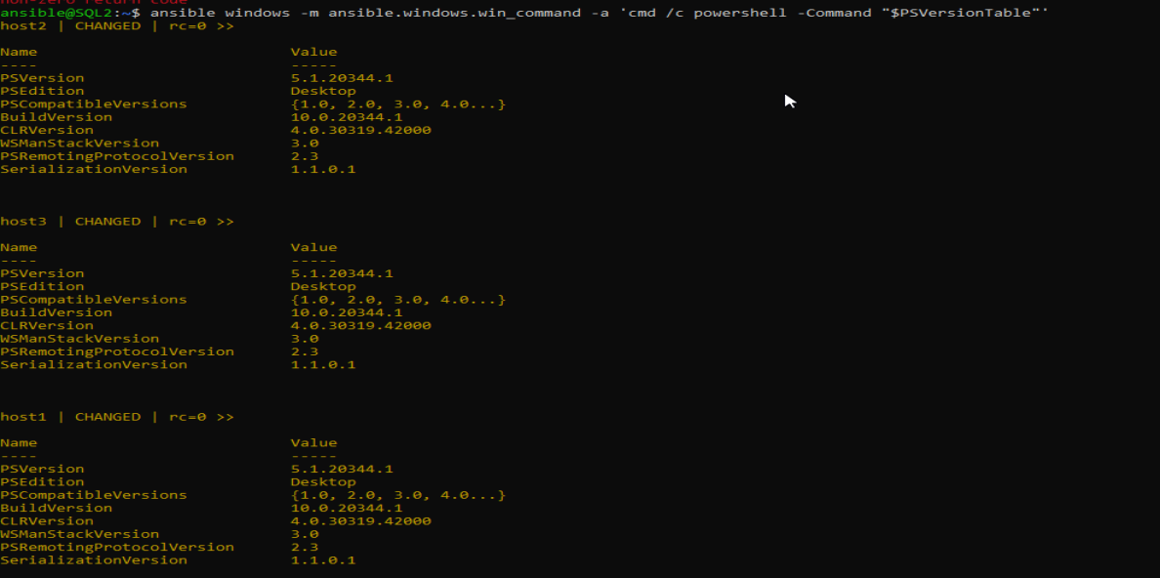

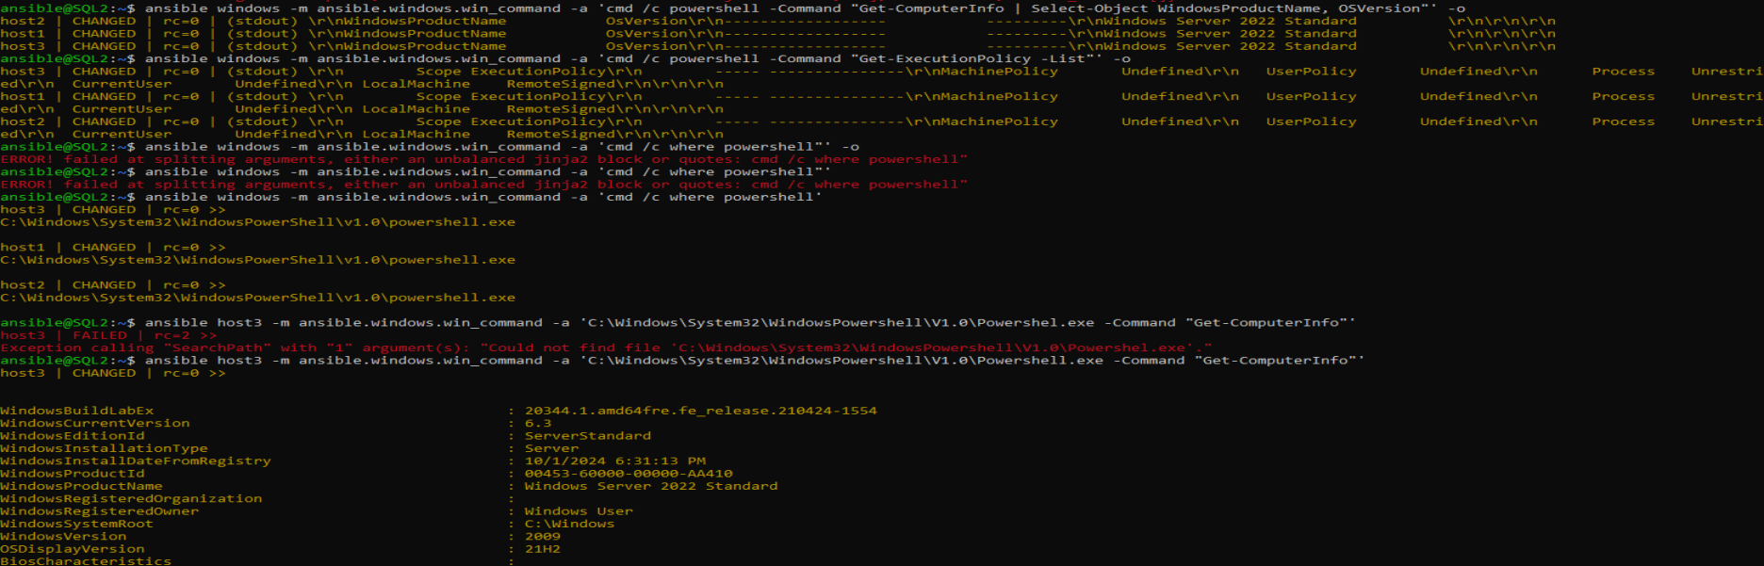

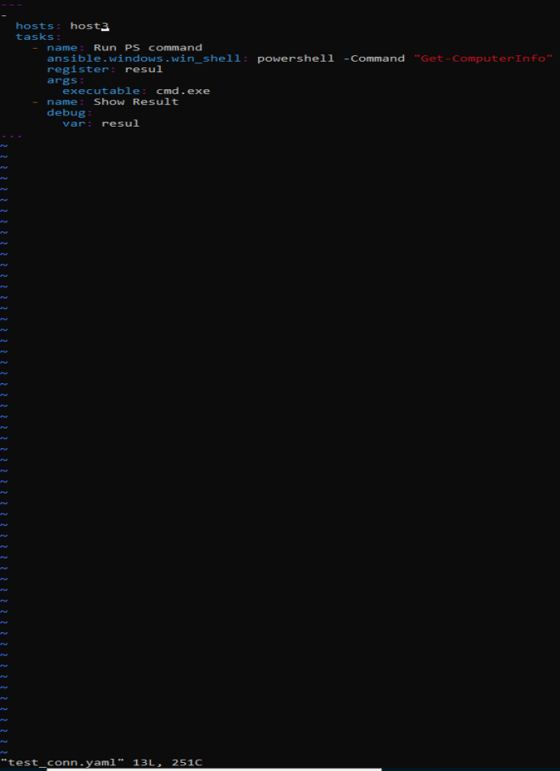

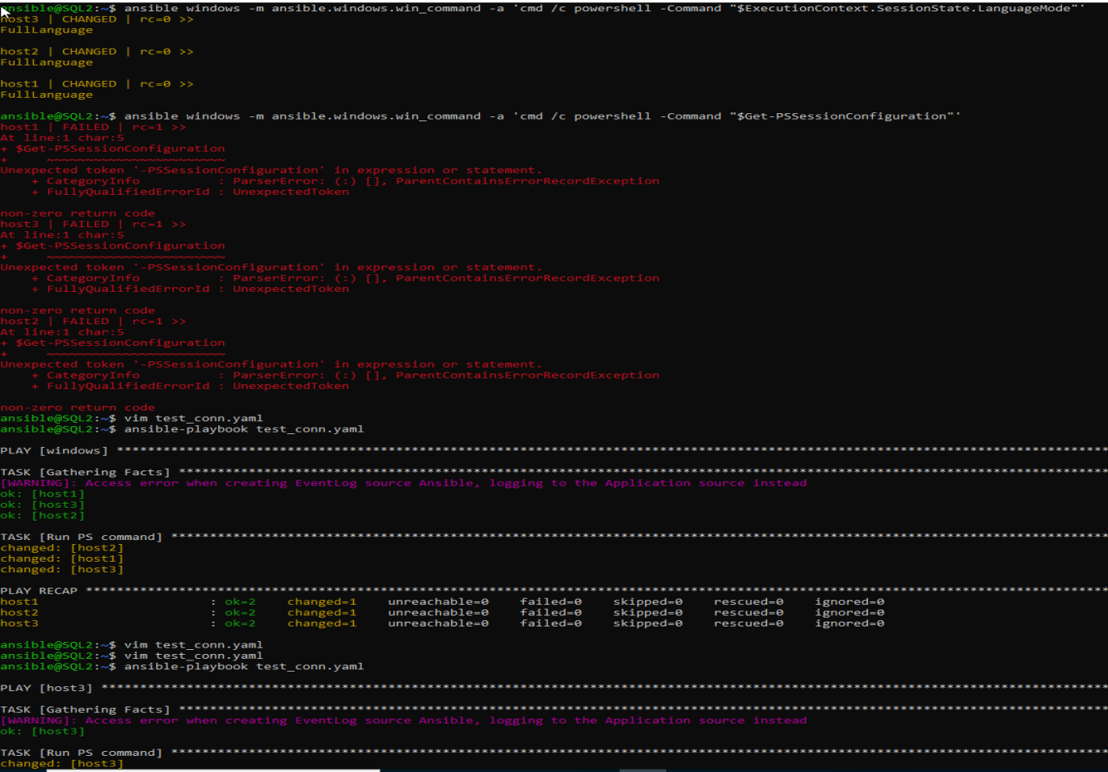

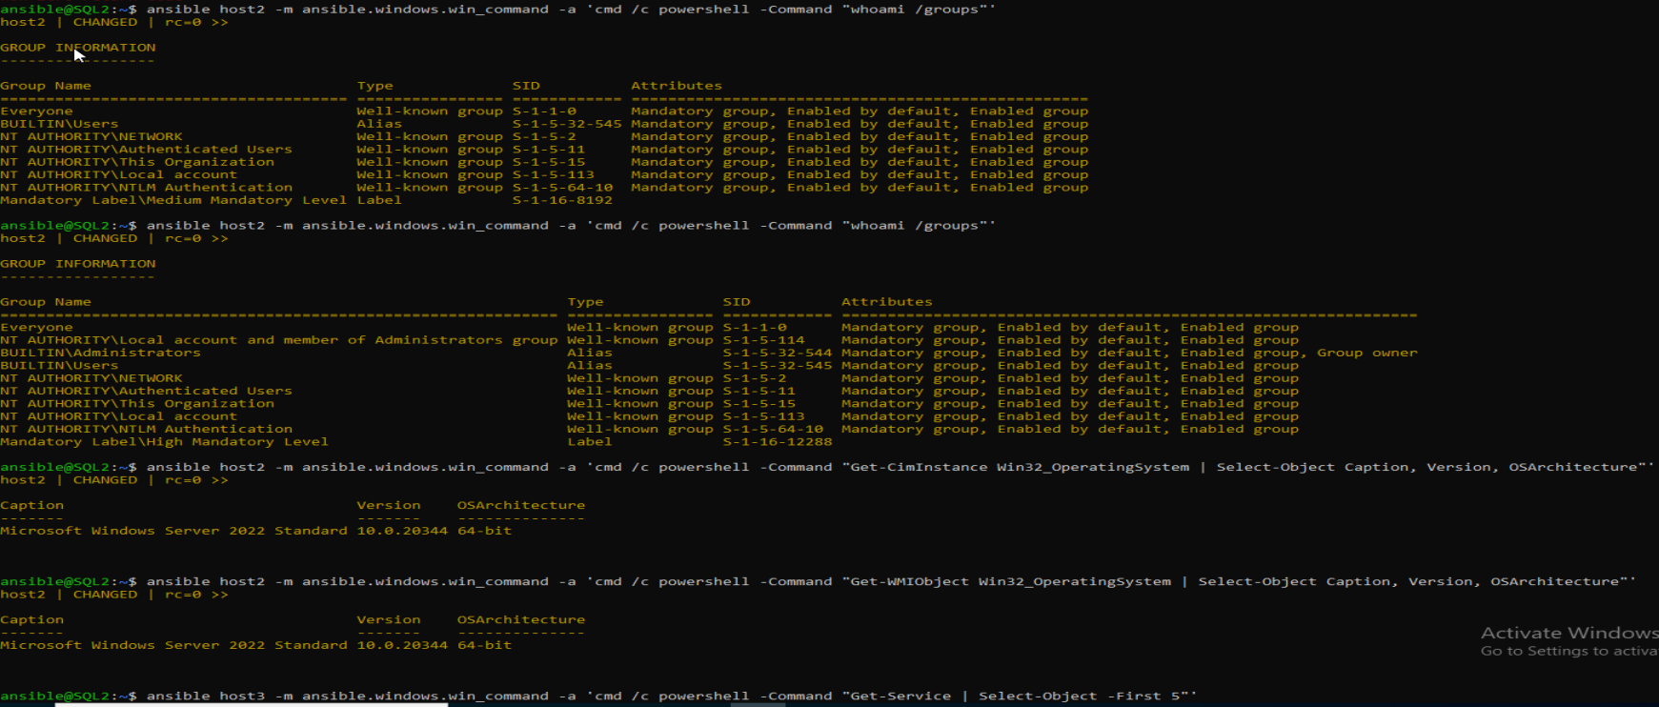

Make sure the user has highest priviliges to run get-wmiobject/get-service commands in powershell on the windows hosts

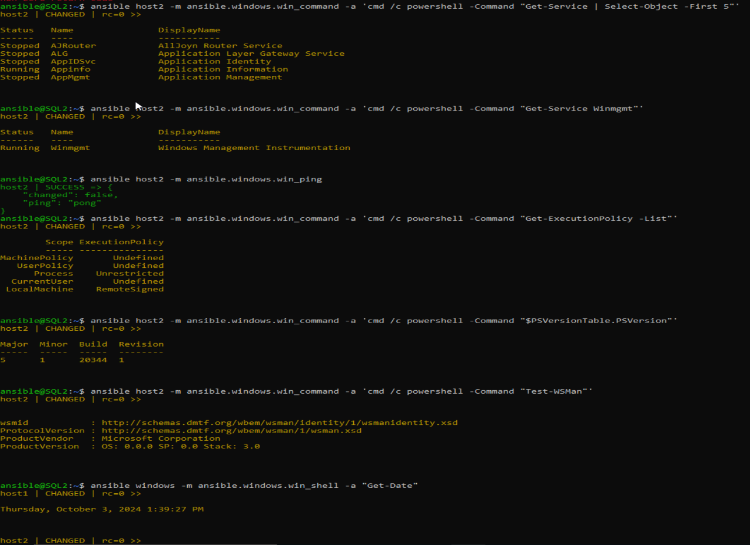

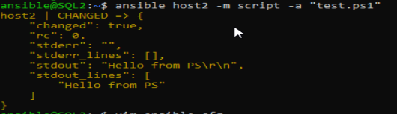

Inventory and config files:

